Daniel
- Pyrate Captain
- Member

- 652 posts
- Gender:Male
- Location:McLean, VA
- Interests:History, pirates, fiction, writing, writing historical fiction about pirates, jokes, games, law.
Posted June 5, 2010 · Report post
I'm trying to find out what maps of the Atlantic would have been available to navigators in 1714, the end of the War of the Spanish Succession. Dampier's journals were available of course, but the only maps of his I've been able to find show only the Caribbean, Central America, and the Indian Ocean. Woodes Rogers' maps would have been complete, but were they published and in circulation? All the Herman Moll maps I've been able to find postdate 1714.
Anyone know which maps were known, and were popularly used? The Atlantic was one of the most traveled oceans in the world; I would have thought it was mapped abundantly.

Fox
- Old Twillian
- Moderator

- 2,564 posts
- Gender:Male
- Location:Beautiful lush Devon, England
- Interests:Nautical history of the 16-18th centuries and living history based thereon.
Shooting pirates.
Posted June 5, 2010 · Report post
Edmund Halley conducted a survey of the Atlantic in the 1690s and the resulting maps were published in the same decade. I'm not sure how widespread they were in 1714, but they were available. They are well detailed and I have a repro of one showing lines of compass variation.

Daniel
- Pyrate Captain
- Member

- 652 posts
- Gender:Male
- Location:McLean, VA
- Interests:History, pirates, fiction, writing, writing historical fiction about pirates, jokes, games, law.
Posted June 5, 2010 · Report post
On 6/5/2010 at 5:19 PM, Foxe said:
Edmund Halley conducted a survey of the Atlantic in the 1690s and the resulting maps were published in the same decade. I'm not sure how widespread they were in 1714, but they were available. They are well detailed and I have a repro of one showing lines of compass variation.
Perfect! Is this the one?
In the past few hours I've also found some world maps that show the Atlantic, in a book called The Image of the World: 20 centuries of World Maps, by Peter Whitfield. It has a world map showing the Atlantic by Adam Friedrich Zuerner, from Saxony, published by Amsterdam cartographer Pieter Schenck in several atlases from about 1710 onwards.

Fox
- Old Twillian
- Moderator

- 2,564 posts
- Gender:Male
- Location:Beautiful lush Devon, England
- Interests:Nautical history of the 16-18th centuries and living history based thereon.
Shooting pirates.
Posted June 6, 2010 · Report post
On 6/5/2010 at 8:02 PM, Daniel said:
Perfect! Is this the one?
Yup, that's the fella.

Karadimos
- Ship's Master
- Member

- 121 posts
- Gender:Female
- Location:Alaska
- Interests:Pirates, History, Writing, Painting, Films, Afterlife, Paranormal, Traveling, Comics, Working Out, Yoga, Cooking, Baking, Coffee, Tea, Music.
Degree in 2D Animation. Nearly have a second degree.
Posted June 6, 2010 · Report post
There's also a big thick book called "Atlas Major of 1665" by Joan Blaeu. It's a reprint of an old atlas from 1665 and it's in English, French, and German. http://www.amazon.com/Atlas-Maior-1665-Joan-Blaeu/dp/3822831255/ref=sr_1_1?ie=UTF8&s=books&qid=1275872243&sr=8-1
I found my copy in the bargain book section at Barnes & Noble

PoD
- Pyrate Captain
- Member

- 696 posts
- Gender:Male
- Location:Warrington UK
- Interests:Pirates, graphic novels, computer art, Listening to music, Going to gigs, Beer and Wine drinking, historical research, Period weaponry and Leatherwork
Posted June 7, 2010 · Report post
There was this English Chart from 1707 that showed the majority of the Atlantic Ocean. I am just doing one of my replica versions of it now.
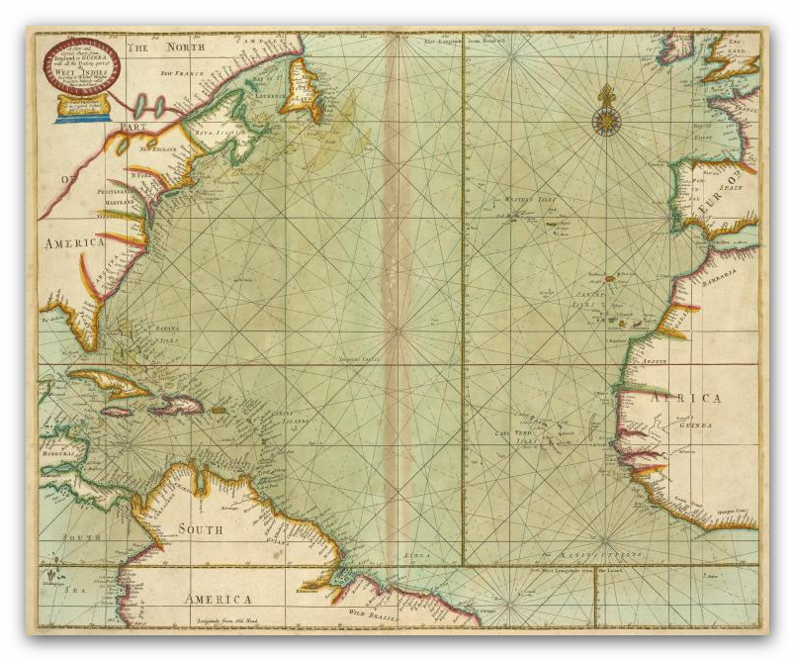

PoD
- Pyrate Captain
- Member

- 696 posts
- Gender:Male
- Location:Warrington UK
- Interests:Pirates, graphic novels, computer art, Listening to music, Going to gigs, Beer and Wine drinking, historical research, Period weaponry and Leatherwork
Posted June 7, 2010 · Report post
On 6/6/2010 at 10:27 AM, Foxe said:
On 6/5/2010 at 8:02 PM, Daniel said:
Perfect! Is this the one?
Yup, that's the fella.
I also do the 1706 color version of that Map
